

**DR.BABASAHEB AMBEDKAR MARATHWADA UNIVERSITY.  
AURANGABAD.**  
   
**MGM  
Dr. G. Y. Pathrikar College of   
Computer Science and Information Technology  
Aurangabad-431001.  
2018-2019  
A  
Project Report  
on**  
**“Vehicle Rentals”**  
**In partial fulfilment of requirement for the degree of**  
**Bachelor of Computer Science**  
   
**Submitted By  
Akash Shah**  
  
**Guidance By**  
**Mrs.Apurva Dhawale**

   
  **MGM'S**  
Dr. G.Y.Pathrikar college of  
Computer Science and Information Technology  
Aurangabad-431001.  
2018-2019   
   
**CERTIFICATE**  
   
  
  
  
  
  
   
**Submitted by  
 Akash Shah**

H.O.D Guidance by Examiner  
 **Mrs. Apurva Dhawale**



This is to certify that the project report **“Vehicle Rentals"** as partial fullfillment of the course B.Sc. [Computer Science] affillated to Dr. Babasaheb Ambedkar Marathwada University, Aurangabad has been successfully completed during academic year 2018-2019.

**Mr. Sanjay Azade**

Date:

Place: Aurangabad



**MGM’s**

**Dr. G. Y. Pathrikar college of Computer Science**

**and Information Technology, Aurangabad-431001**

**Maharashtra**

**CERTIFICATE**

This is certify that **Mr. Akash Shah** carried out the work embodied in this these entitled **“Vehicle Rentals ”**. This work included in this thesis is original, unless stated otherwise and has not been submitted for other degree. References made to work of others have been cited in the text.

Prof.Ms.Apurva Dhawale

Assistant professor

Department of computer science

Dr. G. Y. Pathrikar college of CS & IT,

Aurangabad.



**MGM’s**

**Dr. G. Y. Pathrikar college of Computer Science**

**and Information Technology, Aurangabad-431001**

**Maharashtra**

**CERTIFICATE**

This is certify that **Mr. Akash Shah** carried out the work emboided in this thesis entitled **“Vehicle Rentals”**.This work included in this thesis is original, unless stated otherwise and has not been submitted for other degree. References made to work of others have been cited in the text.

H.O.D

Guide

Examiner

Mr.Sanjay Azade

Ms.Apurva Dhawala

**ACKNOWLEDGEMENT**

“Task successful” makes everyone happy. But happiness will be gold without glitter if we didn’t state the person who have supported us to make it a success.

Success will be crowned to people who made it reality but people who’s constant guidance and encouragement made it possible will be crowned first on the eve of success.

This acknowledgement transcend the reality of the formality when we would like to express deep gratitude and respect to all this people behind the screen who guided, inspired and helped me for the completion of our project.

I consider my self lucky enough to get such good project. This project would add as a asset to my academic profile.

We are also thankful to our **principle Dr.Prapti Deshmukh** our **H.O.D Prof.Mr.Sanjay Azade** for providing support. We are also thankful to all the college staff.

I would like to express my thankfulness to my **project guide Prof. Ms. Apurva Dhawale** for her constant motivation and valuable help through the project work and for her constant supervision, guidance and co-operation through out the project.

I also extend my thanks to my team members for their co-operation during my course.

Finally I would like tothanks my friends for their co-operation to complete this project.

**Organization profile**

Index

|  |  |  |
| --- | --- | --- |
| **Sr.no.** | **Content** | **Page no.** |
| 1 | Introduction | 8 |
| 2 | Abstract of the system | 10 |
| 3 | System requirements | 11 |
| 4 | Software requirements | 13 |
| 5 | Methodology , ER-Diagram and DFD | 15 |
| 6 | Source code | 30 |
| 7 | Output screens | 42 |
| 8 | Enhancement | 55 |
| 9 | Conclusion | 55 |
| 10 | System limitations | 55 |
| 11 | Future scope | 56 |
| 12 | Reference | 56 |

**Introduction**

**Vehicle Rental in India**

India, known as the biggest tourist destination consisting of Munnar in Kerala,beach shacks and dolphin spotting cruise in Goa, Taj Mahal and Agra Fort in Agra,Humayun's Tomb in Delhi,, and of course India Gate . You can enjoy it all via boarding a flight, train or bus to the place but there is no experience such as wandering on a bike or car. The fun gets multiplied. If we have your affirmation on this then vehicle rental in India service is here for you. So, hire bike or car in India and the experience it all from a new perspective.   
  
As soon as you set the foot in India, you come across a number of tourist cruising away on bikes and cars. Cutting through the coastal breeze along the horizon of the Arabian sea gives you a grand feeling and this is what lures people to rent a bike or car in India. When you rent a bike, you don’t only hire that but also the freedom of where you go and when you go. A liberty that you get only when you self drive bike or car in India. There is no nagging, you just get the keys to your favourite bike or car and begin your ride to conquer a land which is a bit distinctive from rest of the country. With Vehicle Rentals, you have the widest range of bike or car to choose from starting with iconic bike Royal Enfield Classic 350, Royal Enfield Thunderbird 350, moving to cruiser-Bajaj Avenger Street 220, commuter-Yamaha FZ, Yamaha R15, Yamaha Fascino, naked motorcycle-Benelli 600i TnT, one of the best 200cc bikes-Bajaj Pulsar RS 200.   
  
The Vehicle Rentals also proffers its customers to rent Harley in India. A trip to India on dream bike or car is no less than a fantasy. You have options to select from Harley Davidson Iron 883, Harley Davidson Street 750, and Harley Davidson Roadster for a full-throttled experience. Similarly, hire KTM in India for a splendid experience. You have multiple options for this design and feature-rich bike- KTM Duke 200, KTM Duke 390, KTM RC 200. And when it comes to our service of sports bike or car rental in India, we become speechless as you make the most of your trip on those wheels!

You must have seen in movies or heard from friends and family that exploring India on scooty has its own charm. Book scooty on rent in India for local commute. Choose between trendy Honda Activa or Honda Dio and commence your tour in the morning. Marvel at the beauty of some famous beaches- Colva beach, Palolem beach, Baga beach, followed by visiting the remains of St. Francis Xavier, watching breathtaking convergence of rivers, Mandovi and Zuari, into the Arabian Sea in Goa. One of the best features of renting a bike or car is that you can do so on monthly, weekly and even hourly basis. Why empty your pockets when you need a motorcycle only for few hours. Or if you are in India only for a long weekend then Vehicle Rentals gives you the service of renting gear & gearless bike(s) only for that duration as well.   
  
With Vehicle Rentals, it’s time to explore India on two and four wheels!

**Abstract of the project**

The project is aimed at developing an Vehicles Rentals for the facilities. This is an intranet based application that can be accessed throughout the facilities across India. This system can be used to automate the workflow of service requests for the various facilities. This is one integrated system that covers different kinds of facilities like cars and bikes. Registered users will be able to log in a request for service for any of the supported facilities. These requests for service for any of the supported facilities. These requests will be sent to the concerned people, who are also valid users of the system, to get them resolved.

The system is developed using advanced technologies like HTML,PHP, CSS as front end and XAMP SQLSERVER as back end.

This Vehicle Rentals will provide services all across India.

This system is applicable for only facilated hubs across India, with full insured cars and bikes. The vehicles has to be picked up by the customer from the nearest hub near him. The Rents of cars and bikes are different. The cars are given to customers with kilometer reference. The bikes are given with time reference.

The bikes and cars should be picked up from booking time to next two hours of the day or else the charges will be applied from that time.

**System requirements**

**Hardware Requirement:-**

* Pentium-IV
* 256 MB Ram
* 512 KB Cache Memory
* Hard disk 20 GB
* Microsoft Compatible 101 or more key board

**Software Requirements:-**

* Software : Sublime text, XAMP control panel.
* Programming language : HTML,CSS,PHP,
* Web-Technology : PHP
* Front-End : PHP,HTML
* Back-End: MY SQL
* Web-Server : XAMP Server

**Software requirements**

The software requirement specification is produced at the culmination of the analysis task.The function and performance allocated to software as part of system enginnering are refined by established complete information description,a detailed functional description ,a representation of system behavior,an indication of performance requirement and design constraints validation criteria, and other information pertiment to requirement.

The introduction to software requirement specification states the goals and objective of the software, describing it in the context of the computer based system. The information Description provides a detailed descriptionof the problem that the software must solve.Information content,flow and structure are documented. A description of each function required to solve the problem is presented in the Functional Description.

Validation Criteria is probably the most important and ironically the most often neglected section of the software requirement specification.

Software requirement specification can be used for different purpose. Here are the major user.not clearly understood by the developer. If this is the case, a careful analysis- involving much interaction with the user should be developed to reaching a clear statement of requirement, in order to avoid possible misunderstanding.

Sometimes, at the beginning of a project, even the usewr has no clear idea of what exactly the desired product. Think for instance of user has interface , a user with no previous experience with computer product may not appreciate the difference between , say menu driven interaction and a command line interface.

Even an exact formation of system function and performance may be missing an initial description produced by an inexperienced user.

A statement of the requirement for the implementation:

Specification are also used as a reference point during product implantation. In fast, the ultimate goal of the implementation is to build a product that needs specification. Thus the implementers use specification during design to make design decision and during the verification activity to check that the implementation complete with specification.

**Methodology** **ER-Diagram**

**and DFD**

**PHP**

PHP started out as a small open source project that evolved as more and more people found out how useful it was. Rasmus Lerdorf unleashed the first version of PHP way back in 1994.

PHP is a recursive acronym for "PHP: Hypertext Preprocessor".

PHP is a server side scripting language that is embedded in HTML. It is used to manage dynamic content, databases, session tracking, even build entire e-commerce sites.

It is integrated with a number of popular databases, including MySQL, PostgreSQL, Oracle, Sybase, Informix, and Microsoft SQL Server.

PHP is pleasingly zippy in its execution, especially when compiled as an Apache module on the Unix side. The MySQL server, once started, executes even very complex queries with huge result sets in record-setting time.

PHP supports a large number of major protocols such as POP3, IMAP, and LDAP. PHP4 added support for Java and distributed object architectures (COM and CORBA), making n-tier development a possibility for the first time.

PHP is forgiving: PHP language tries to be as forgiving as possible.

PHP Syntax is C-Like.

**Example : -**"Hello World" Script in PHP

To get a feel for PHP, first start with simple PHP scripts. Since "Hello, World!" is an essential example, first we will create a friendly little "Hello, World!" script.

As mentioned earlier, PHP is embedded in HTML. That means that in amongst your normal HTML (or XHTML if you're cutting-edge) you'll have PHP statements like this −

<html>

<head>

<title>Hello World</title>

</head> <body>

<?php echo "Hello, World!";?>

</body>

</html>

**HTML**

HTML stands for Hyper Text Markup Language, which is the most widely used language on Web to develop web pages. HTML was created by Berners-Lee in late 1991 but "HTML 2.0" was the first standard HTML specification which was published in 1995. HTML 4.01 was a major version of HTML and it was published in late 1999. Though HTML 4.01 version is widely used but currently we are having HTML-5 version which is an extension to HTML 4.01, and this version was published in 2012.

Hypertext refers to the way in which Web pages (HTML documents) are linked together. Thus, the link available on a webpage is called Hypertext.

As its name suggests, HTML is a MarkupLanguage which means you use HTML to simply "mark-up" a text document with tags that tell a Web browser how to structure it to display.

Originally, HTML was developed with the intent of defining the structure of documents like headings, paragraphs, lists, and so forth to facilitate the sharing of scientific information between researchers.

Now, HTML is being widely used to format web pages with the help of different tags available in HTML language.

Example : -

<!DOCTYPE html>

<html>

<head>

<title>This is document title</title>

</head>

<body>

<h1>This is a heading</h1>

<p>Document content goes here.....</p>

</body>

</html>

**CSS**

CSS is used to control the style of a web document in a simple and easy way.

CSS is the acronym for "Cascading Style Sheet". This tutorial covers both the versions CSS1,CSS2 and CSS3, and gives a complete understanding of CSS, starting from its basics to advanced concepts.

**C**ascading **S**tyle **S**heets, fondly referred to as CSS, is a simple design language intended to simplify the process of making web pages presentable.

CSS handles the look and feel part of a web page. Using CSS, you can control the color of the text, the style of fonts, the spacing between paragraphs, how columns are sized and laid out, what background images or colors are used, layout designs,variations in display for different devices and screen sizes as well as a variety of other effects.

CSS is easy to learn and understand but it provides powerful control over the presentation of an HTML document. Most commonly, CSS is combined with the markup languages HTML or XHTML.

A CSS comprises of style rules that are interpreted by the browser and then applied to the corresponding elements in your document. A style rule is made of three parts −

* **Selector** − A selector is an HTML tag at which a style will be applied. This could be any tag like <h1> or <table> etc.
* **Property** − A property is a type of attribute of HTML tag. Put simply, all the HTML attributes are converted into CSS properties. They could be *color*, *border* etc.
* **Value** − Values are assigned to properties. For example, *color*property can have value either *red* or *#F1F1F1* etc.

You can put CSS Style Rule Syntax as follows −

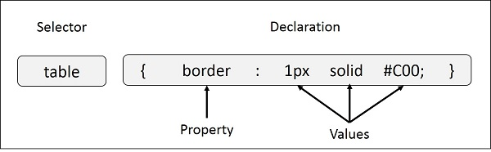

Multiple Style Rules

You may need to define multiple style rules for a single element. You can define these rules to combine multiple properties and corresponding values into a single block as defined in the following example −

h1 {

color: #36C;

font-weight: normal;

letter-spacing: .4em;

margin-bottom: 1em;

text-transform: lowercase;

}

**MySQL**

MySQL is a Relational DataBase Management System (RDBMS).

RDBMS means R--DB--MS.

- DB stands for Database, a repository for the information store.

* The data in a database is organized into tables, and each table is organized into rows and columns.
* Each row in a table is called a record. A record may contains several pieces (called fields) of information, and each column in a table is known as a field.

-MS stands for Management System, the software that allows you to insert, retrieve, modify, or delete records.

-R stands for Relational, indicates a particular kind of DBMS that is good at relating information stored in one table to information stored in another table by looking for elements common to each of them. Relational DBMS has the advantage of efficient storage, and retrieval mechanisms for data, and uses normalization process during design of RDBMS. Database normalization process is beyond the scope of this article, and several references are available.

MySQL operates using client/server architecture in which the server runs on the machine containing the databases and clients connect to the server over a network. The server operating systems is usually a Linux (like Redhat 9.0 etc.) or Windows 2000 operating system. Typically mySQL is supported on Windows XP, Windows Server 2003, Red Hat Fedora Linux, and Debian Linux, and others. As with any other client/server application, MySQL is a multi-user database system, meaning several users can access the database simultaneously. Here:

-The server (MySQL server) listens for client requests coming in over the network and accesses database contents according to those requests and provides that to the clients.

**Features of MySQL**

* Speed
* Easy to use
* Query language support
* Capability
* Connectivity and security
* Portability

**HTML LAYOUTS**

A webpage layout is very important to give better look to your website. It takes considerable time to design a website's layout with great look and feel.

Now-a-days, all modern websites are using CSS and JavaScript based framework to come up with responsive and dynamic websites but you can create a good layout using simple HTML tables or division tags in combination with other formatting tags.

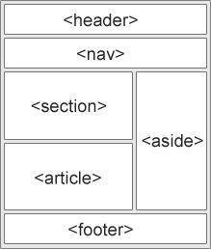

* <header> - Defines a header for a document or a section.
* <nav> - Defines a container for navigation links.
* <section> - Defines a section in a document.
* <article> - Defines an independent self-contained article.
* <aside> - Defines content aside from the content (like a sidebar).
* <footer> - Defines a footer for a document or a section.
* <details> - Defines additional details.
* <summary> - Defines a heading for the <details> element.

**HTML BASIC TAGS**

**1] Body tag :-**

The HTML **<body> tag**defines the main content of the HTML document or the section of the HTML document that will be directly visible on your web page. This tag is also commonly referred to as the <body> element.

**Syntax**:- In HTML, the syntax for the **<body> tag** is:

<body> content … </body>

**2] Headings tag :-**

Any document starts with a heading. You can use different sizes for your headings. HTML also has six levels of headings, which use the elements <h1>, <h2>, <h3>, <h4>, <h5>, and <h6>. While displaying any heading, browser adds one line before and one line after that heading.

**Syntax**:- <h1>Heading 1</h1>

**3] Paragraph Tag:-**

The **<p>** tag offers a way to structure your text into different paragraphs. Each paragraph of text should go in between an opening <p> and a closing </p> tag as shown below in the syntax−

**Syntax**:-<p>this is paragraph</p>

**4] Centering Content :-**

You can use **<center>** tag to put any content in the center of the page or any table cell.

**Syntax**:- <center> content </center>

**5]Div tag :-**

The <div> tag defines a division or a section in an HTML document.The <div> element is often used as a container for other HTML elements to style them with CSS or to perform certain tasks with JavaScript.

**Syntax** :- <div>

</div>

**6] Line Break Tag :-**

Whenever you use the **<br />** element, anything following it starts from the next line. This tag is an example of an **empty** element, where you do not need opening and closing tags, as there is nothing to go in between them.

The <br /> tag has a space between the characters **br** and the forward slash. If you omit this space, older browsers will have trouble rendering the line break, while if you miss the forward slash character and just use <br> it is not valid in XHTML.

**Syntax**:- <p>Hello<br /> hi<br /> Thanks</p>

**7]Script tag :-**

The <script> tag is used to define a client-side script (JavaScript).The <script> element either contains scripting statements, or it points to an external script file through the src attribute.

Common uses for JavaScript are image manipulation, form validation, and dynamic changes of content

**Syntax** :-<script>

</script>

The <script> tag is used for designing purpose also.

**8]Links tag:-**

A webpage can contain various links that take you directly to other pages and even specific parts of a given page. These links are known as hyperlinks.

**Syntax:-**

<a href = "Document URL" ... attributes-list>Link Text</a>

**9]Image tag :-**

Images can improve the design and the appereance of a web page. The webpage look very attractive using images ,it also improve user’s interaction the webpage.

**Syntax** :- <img src = “path of image” border=” ”>

In above syntax path of the image should be given and image shoukd have a extension of ‘.jepg or .png’.

**Home page**

As the home page is the which has to be link with many of pages of website . So, the few navigation links are shown at the top right corner. And the logo of the organization is at the top left. A beautiful welcome thought is shown below . And just below the welcome thought the two more navigation links of different pages are added. Then the background bikes video is display and right side of it a slogan is display about enjoyment while riding bikes .

The exciting thing that every website contains is offers, are display with the crazy minions at the background gif .The offers always attracts people so we have shown the 50% off offer in our website .The step to book the vehicle from our website are display so the users may not get confuse and they will understand easily how to book vehicles.

As the website is about vehicle rent to ride over different place to make our days .So the best places to visit in India are display. Everyone in world knows that Taj Mahal is one of the seven wonders of the world . Some more beautiful place are display .At the last that every website has is the details of the website are given and the contact information is display .

**Map page**

The map page in our project is something new that we have applied in our project. The basically shows that where vehicle rental hubs are located.

A user can check whether there is a hub of vehicle rentals is their or not by looking to a map one can easily check whether its near by or not.

If one doesn’t found a near by hub then he can checked which is the nearest hub is their around him or where he wants to go. Then he can checked whether he can afford a rental or not. By checking it he can make sure whether its an affordable rental is or not.

**Login page**

A login is the entering of identify information into our vehicle rental system websites. It is an integral part of our websites.

A login generally requires the user to enter two pieces of information, first a user name and then a password. This information enter on a login window on the command line in a console depending upon the system.

A user name also referred to as an account name is string (that is sequence of character ) That uniquely identifies a user. Users name can be the same as or related to the real names of users , or they can be completely arbitrary

A password is likewise a string but it differs from a user name in that it is intended to be kept secret that is known only to its user and, perhaps to the system administration.

**Registration page**

The registration is required to make the login id for the specific website. So the registration page in our website four text fields are display where user have to enter his/her name ,email, password and confirm password. These detail are required compulsory to register in our website .

As you can se in our website that the registration and login are much similar to each other in design .In fact the background is also similar .

The button is display below the confirm password field , when user will click on it his /her account will get register in our website . If the user already have the account in our website .Then he/she can select the sign in option which display just below the register button.

**ER-Diagram :-**

Close

Start

Login

register

City location

Booking

Payment

Cars

Bikes

**Data Flow Diagram**

User vehicle booking

City location

d

Registration

Login

Select

bikes

cars

City location

d

d

d

d

Booking data

Vehicles

users

Payment

**Source Code**

**//Home page**

<!DOCTYPE html>

<html>

<head>

<title>Vehicle Rentals</title>

<link rel="shortcut icon" href="video/dfhvahsvfajkgfkf.png">

<link rel="stylesheet" type="text/css" href="css/firststyle.css">

<link href="https://fonts.googleapis.com/css?family=Flamenco" rel="stylesheet">

<link rel="stylesheet" href="https://cdnjs.cloudflare.com/ajax/libs/animate.css/3.7.0/animate.min.css">

<link rel="stylesheet" href="https://cdnjs.cloudflare.com/ajax/libs/font-awesome/4.7.0/css/font-awesome.min.css">

</head>

<body>

<header>

<nav>

<div class="row clearfix">

<img src="images/log.png" class="logo">

<ul class="main-nav animated rubberBand " id="ckeck-class">

<li><a href="firstpage.php">Home</a></li>

<li><a href="aboutus.php">About Us</a></li>

<li><a href="policy.php">Policy</a></li>

<li><a href="register.php">Sign up</a></li>

<li><a href="login.php">Login</a></li>

</ul>

<a href="#" class="mobile-icon" onclick="slideshow()">

<i class="fa fa-bars" ></i></a>

</div>

</nav>

<div class="main-content-header">

<h1>WELCOME TO <span class="colorchange ">VEHICLE RENTALS</span>.<br>

HOUSE OF TRAVELING LOVERS. </h1>

<a href="option.php" class="btn btn-full animated jello">click to order</a>

<a href="map.php" class="btn btn-nav animated jello">select location</a>

</div>

</header>

<section>

<div> <p> </p>

</div>

<article>

<div class="quote">

<h1><span class="colorstyle">Travel makes one modest, you see what a tiny place you occupy in the world.One's destination is never a place, but a new way of seeing things.</span></h1>

</div>

</article>

</section></body> </html>

**//Login Page**

<!DOCTYPE html>

<html>

<head>

<title>Login</title>

<link rel="shortcut icon" href="video/dfhvahsvfajkgfkf.png">

<link rel="stylesheet" type="text/css" href="css/regstyle.css">

</head>

<body>

<div class="header">

<h2>Login</h2>

</div>

<form method="POST" action="">

<div class="input-group">

<label>Email</label>

<input type="text" name="email">

<div class="input-group">

<label>password</label>

<input type="password" name="password_1">

</div>

<div class="input-group">

<div class="btn">

<input type="submit" name="submit" value="Login">

</div>

</div>

<p>

Not yet a member?<a href="register.php">Sign up</a>

</p>

</form>

</body>

</html>

<div class="input-group">

<div class="btn">

<input type="submit" name="submit" value="Login">

</div>

</div>

<p>

Not yet a member?<a href="register.php">Sign up</a>

</p>

</form>

</body>

</html>

**//Registration Page**

<?php include('server1.php'); ?>

<!DOCTYPE html>

<html>

<head>

<title>registerion</title>

<link rel="shortcut icon" href="video/dfhvahsvfajkgfkf.png">

<link rel="stylesheet" type="text/css" href="css/regstyle.css">

</head>

<body> <div class="header">

<h2>Register</h2>

</div> <form method="POST" action="register.php">

<!-- display validation error here -->

<?php include('errors.php'); ?>

<div class="input-group">

<label>Username</label>

<input type="text" name="username">

</div>

<div class="input-group">

<label>email</label>

<input type="text" name="email">

</div>

<div class="input-group">

<label>password</label>

<input type="password" name="password_1">

</div>

<div class="input-group">

<label>confirm-password</label>

<input type="password" name="password_2">

</div>

<div class="input-group">

<div class="btn">

<input type="submit" name="signup" value="Register">

</div>

</div>

<p>Already a member?<a href="login.php">Sign in</a></p>

</form>

</body>

</html>

**//Map Page**

<!DOCTYPE html>

<html>

<head>

<script src="jquery-2.1.4.js"></script>

<title>map</title>

<link rel="stylesheet" type="text/css" href="css/mapstyle.css">

<link rel="shortcut icon" href="video/dfhvahsvfajkgfkf.png">

</head>

<body>

<nav>

<div class="backgro" style="height: 200px">

<img src="images/log.png" class="logo" >

<ul class="main-nav " id="ckeck-class">

<li><a href="firstpage.php">Home</a></li>

<li><a href="aboutus.php">About Us</a></li>

<li><a href="policy.php">Policy</a></li>

<li><a href="register.php">Sign up</a></li>

<li><a href="login.php">Login</a></li>

</ul>

</div>

</nav>

<div class="top" style="text-align: center;" >

Where Vehicle Rentals are available in INDIA

</div>

<div class="map">

<iframe src="https://www.google.com.qa/maps/d/embed?mid=1RrCYASUfulW27sRLhFdTdL3V2liYMG3j" width="90%" height="600" frameborder="0" style="border:0" allowfullscreen></iframe>

</div>

</body>

</html>

**//Order confirm Page**

<!DOCTYPE html>

<html>

<head>

<script src="jquery-2.1.4.js"></script>

<title>Comment Form </title>

<link rel="stylesheet" type="text/css" href="css/confirmstyle.css">

<link rel="shortcut icon" href="video/dfhvahsvfajkgfkf.png">

</head>

<body>

<form method="POST" action="" class="top">

<div class="wrapper">

<nav>

<div class="backgro" style="height: 200px">

<img src="images/log.png" class="logo" >

<ul class="main-nav " id="ckeck-class">

<li><a href="firstpage.php">Home</a></li>

<li><a href="aboutus.php">About Us</a></li>

<li><a href="policy.php">Policy</a></li>

<li><a href="register.php">Sign up</a></li>

<li><a href="login.php">Login</a></li>

</ul>

</div>

</nav>

<div class="payment">

<span class="colorchange " style="font-size: 30px;">YOUR ORDER HAVE BEEN CONFIRM...</span>

<div>

<br style="font-size: 25px;">Comment: <br>

<label class="label"> </label>

<textarea name="views" rows="6" cols="50" style="font-size: 16px; " placeholder="How was your experience with us ?">

</textarea>

</div>

<button type="submit" class="submit" name="submit">

<a href="" style="text-decoration: none;color: white;font:bolder;">Submit</a>

</button>

</div></div>

</div>

</body>

</html>

**// Cars booking Page**

<!DOCTYPE html>

<html>

<head>

<title>order cars</title>

<link rel="shortcut icon" href="video/dfhvahsvfajkgfkf.png">

<meta charset="utf-8">

<meta name="viewport" content="width=device-width, initial-scale=1">

<link rel="stylesheet" href="https://maxcdn.bootstrapcdn.com/bootstrap/4.2.1/css/bootstrap.min.css">

<script src="https://ajax.googleapis.com/ajax/libs/jquery/3.3.1/jquery.min.js"></script>

<script src="https://cdnjs.cloudflare.com/ajax/libs/popper.js/1.14.6/umd/popper.min.js"></script>

<script src="https://maxcdn.bootstrapcdn.com/bootstrap/4.2.1/js/bootstrap.min.js"></script>

<link rel="stylesheet" href="https://cdnjs.cloudflare.com/ajax/libs/font-awesome/4.7.0/css/font-awesome.min.css">

<link rel="stylesheet" href="https://fonts.googleapis.com/

css?family=Abril+Fatface|Dancing+Script">

<link rel="stylesheet" type="text/css" href="css/carsstyle.css">

</head>

<body>

<nav>

<div class="backgro" style="height: 200px">

<img src="images/log.png" class="logo" >

<ul class="main-nav " id="ckeck-class">

<li><a href="bikes.php">Bikes</a></li>

<li><a href="firstpage.php">Home</a></li>

<li><a href="aboutus.php">About Us</a></li>

<li><a href="policy.php">Policy</a></li>

<li><a href="create.php">Sign up</a></li>

<li><a href="login.php">Login</a></li>

</ul></div> </nav>

<br><br><br>

<div class="container" style="background-color: grey" >

<h1 class="text-center mb-5" style="color: white"><br>

Order Cars From Vehicle Rentals</h1>

<br><br>

<div class="row">

<?PHP

$con = mysqli_connect('localhost','root');

mysqli_select_db($con,'car rentals');

$query ="SELECT `id`, `name`, `image`, `price`, `discount` FROM `carspage` order by id ASC";

$queryfire = mysqli_query($con, $query);

$num = mysqli_num_rows($queryfire);

if($num > 0){

while ($product = mysqli_fetch_array($queryfire)){

?>

<div class="col-lg-3 col-md-3 col-sm-12 mb-5">

<form method="POST" action="book.php">

<div class="card">

<h6 class="card-title bg-info text-white p-2"> <?php echo

$product['name']; ?> </h6>

<div class="card-body">

<img src="<?php echo $product['image']; ?>" alt="cars" class="img-fluid mb-2">

<h6> &#8377; <?php echo

$product['price']; ?>

<span> (<?php echo $product['discount']; ?>% off)</span></h6>

<h6 class="badge badge-success"> 4.4 <i class="fa fa-star"></i></h6>

<div class=""><a href="book.php">

<button class="btn btn-success flex-fill">Order Now </button></a>

</div>

</div></div></form> </div></div> </div>

<br><br>

<div class="contac">

Contact For any Queries please contact<br>

Phone : +91 9028718415<br>

Email: VehicleRentals242@.com<br><br><br><br><br><br>

</div> </body></html>

**// Bikes booking Page**

<!DOCTYPE html>

<html>

<head>

<title>order bikes</title>

<meta charset="utf-8">

<meta name="viewport" content="width=device-width, initial-scale=1">

<link rel="shortcut icon" href="video/dfhvahsvfajkgfkf.png">

<link rel="stylesheet" href="https://maxcdn.bootstrapcdn.com/bootstrap/4.2.1/css/bootstrap.min.css">

<script src="https://ajax.googleapis.com/ajax/libs/jquery/3.3.1/jquery.min.js"></script>

<script src="https://cdnjs.cloudflare.com/ajax/libs/popper.js/1.14.6/umd/popper.min.js"></script>

<script src="https://maxcdn.bootstrapcdn.com/bootstrap/4.2.1/js/bootstrap.min.js"></script>

<link rel="stylesheet" href="https://cdnjs.cloudflare.com/ajax/libs/font-awesome/4.7.0/css/font-awesome.min.css">

<link rel="stylesheet" href="https://fonts.googleapis.com/

css?family=Abril+Fatface|Dancing+Script">

<link rel="stylesheet" type="text/css" href="css/bikestyle.css">

</head><body>

<nav>

<div class="backgro" style="height: 200px">

<img src="images/log.png" class="logo" >

<ul class="main-nav " id="ckeck-class" style="font:bolder;">

<li><a href="cars.php">Cars</a></li>

<li><a href="firstpage.php">Home</a></li>

<li><a href="aboutus.php">About Us</a></li>

<li><a href="policy.php">Policy</a></li>

<li><a href="register.php">Sign up</a></li>

<li><a href="login.php">Login</a></li>

</ul></div></nav>

<br><br><br>

<div class="container" style="background-color: grey" >

<h1 class="text-center mb-5" style="color: white" ><br>

Order Bikes From Vehicle Rentals</h1>

<br><br>

<div class="row">

<?PHP $con = mysqli_connect('localhost','root');

mysqli_select_db($con,'car rentals');

$query ="SELECT `id`, `name`, `image`, `price`, `discount` FROM `bikespage` order by id ASC";

$queryfire = mysqli_query($con, $query);

$num = mysqli_num_rows($queryfire);

if($num > 0){

while ($product = mysqli_fetch_array($queryfire)){

?>

<div class="col-lg-3 col-md-3 col-sm-12 mb-5">

<form method="POST" action="book.php">

<div class="card">

<h6 class="card-title bg-info text-white p-2"> <?php echo

$product['name']; ?> </h6>

<div class="card-body">

<img src="<?php echo $product['image']; ?>" alt="cars" class="img-fluid mb-2">

<h6> &#8377; <?php echo

$product['price']; ?>

<span> (<?php echo $product['discount']; ?>% off)</span></h6>

<h6 class="badge badge-success"> 4.4 <i class="fa fa-star"></i></h6>

<div class=""><a href="book.php">

<button class="btn btn-success flex-fill">Order Now </button></a>

</div> </div> </div> </form>

</div></div> </div> <br><br>

<div class="contac">

Contact For any Queries please contact<br>

Phone : +91 9028718415<br>

Email: VehicleRentals242@.com<br><br><br><br><br><br>

</div>

</body>

</html>

**// Payment booking page**

<!DOCTYPE html>

<html>

<head>

<title>Payment Form</title>

<link rel="stylesheet" href="https://use.fontawesome.com/releases/v5.4.2/css/all.css">

<link rel="stylesheet" type="text/css" href="css/paystyle.css">

<link rel="shortcut icon" href="video/dfhvahsvfajkgfkf.png">

</head>

<body>

<form method="POST" action="">

<div class="wrapper">

<div class="payment">

<div class="payment-logo">

<p style="font-family: cursive;">P</p>

</div>

<h2>Payment Gateway</h2>

<div class="">

<div class="card space icon-relative">

<label class="label">Card holder:</label>

<input type="text" class="input" name="cardholder" placeholder="Card holder" required="">

<i class="fas fa-user"></i>

</div>

<div class="card space icon-relative">

<label class="label">Card number:</label>

<input type="text" class="input" name="cardnumber" data-mask="0000 0000 0000 0000" placeholder="Card Number" required="">

<i class="far fa-credit-card"></i>

</div>

<div class="card-grp space">

<div class="card-item icon-relative">

<label class="label">Expiry date:</label>

<input type="text" name="expirydate" class="input" data-mask="00 / 00" placeholder="00 / 00">

<i class="far fa-calendar-alt"></i>

</div>

<div class="card-item icon-relative">

<label class="label">CVC:</label>

<input type="text" name="cvv" class="input" data-mask="000" placeholder="000">

<i class="fas fa-lock"></i>

</div>

</div>

<div class="btn">

<a href="confirm.php" style="text-decoration: none;color: white;font:bolder;font-size: 20px; color: black;">Pay</a>

</div>

</div>

</div>

</div>

</div>

</div>

</form>

<script src="https://code.jquery.com/jquery-3.3.1.min.js"></script>

<script src="https://cdnjs.cloudflare.com/ajax/libs/jquery.mask/1.14.15/jquery.mask.min.js"></script>

</body>

</html>

**Output screens**

**1.) Home Page**

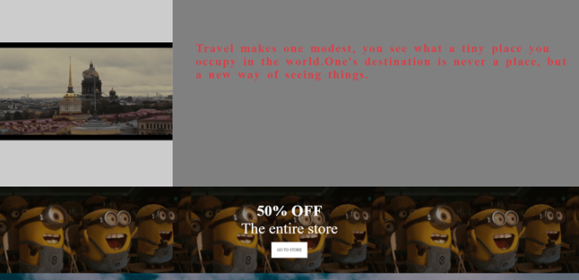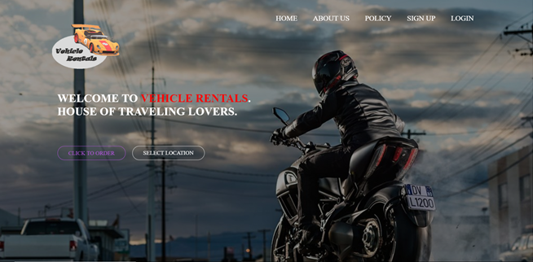

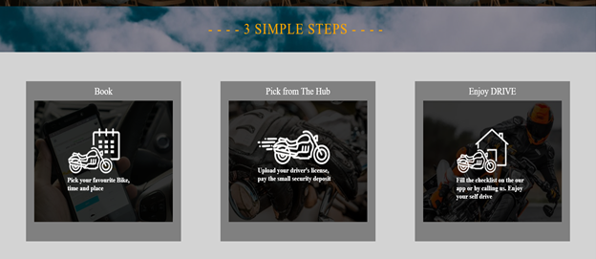

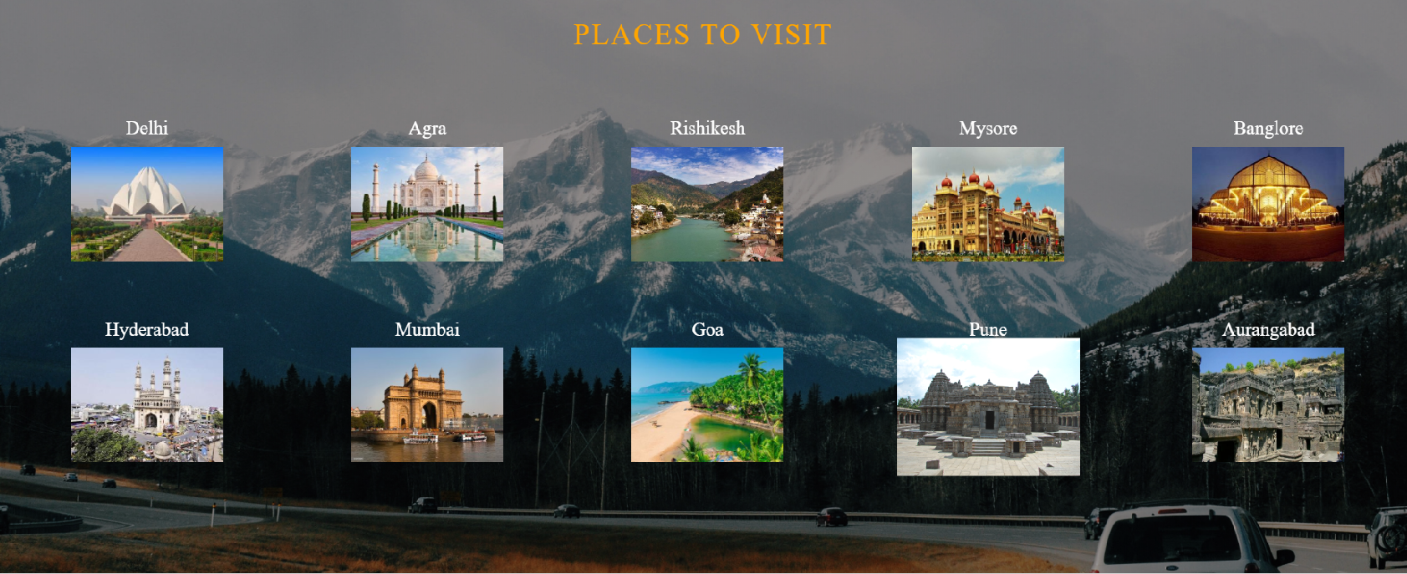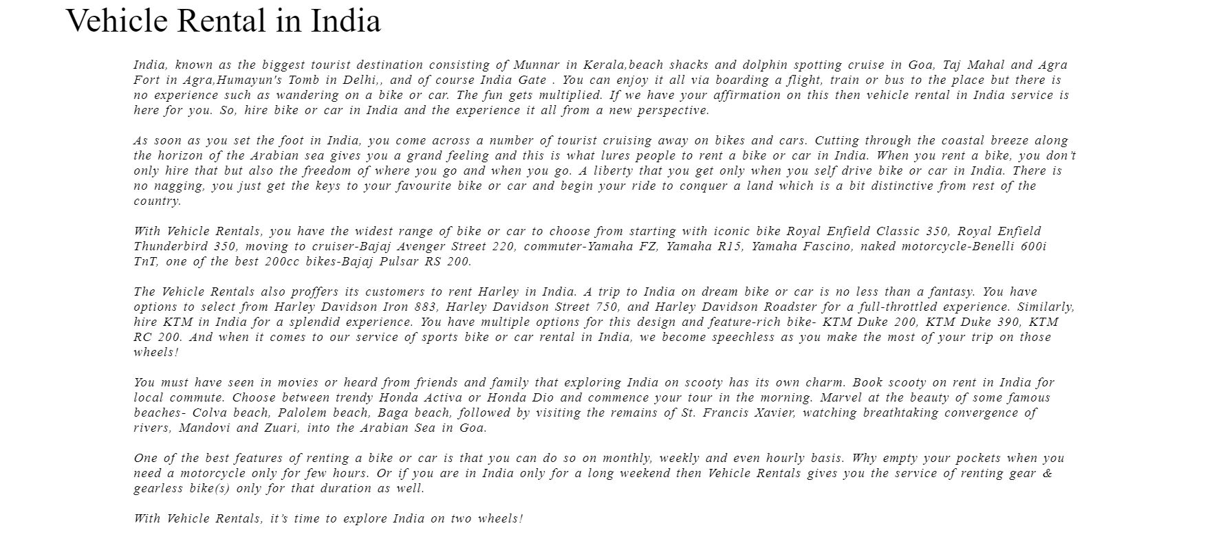

**2.) Register Page**

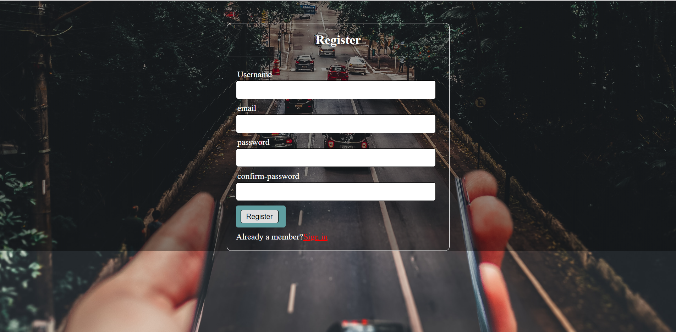

**3.) Login Page**

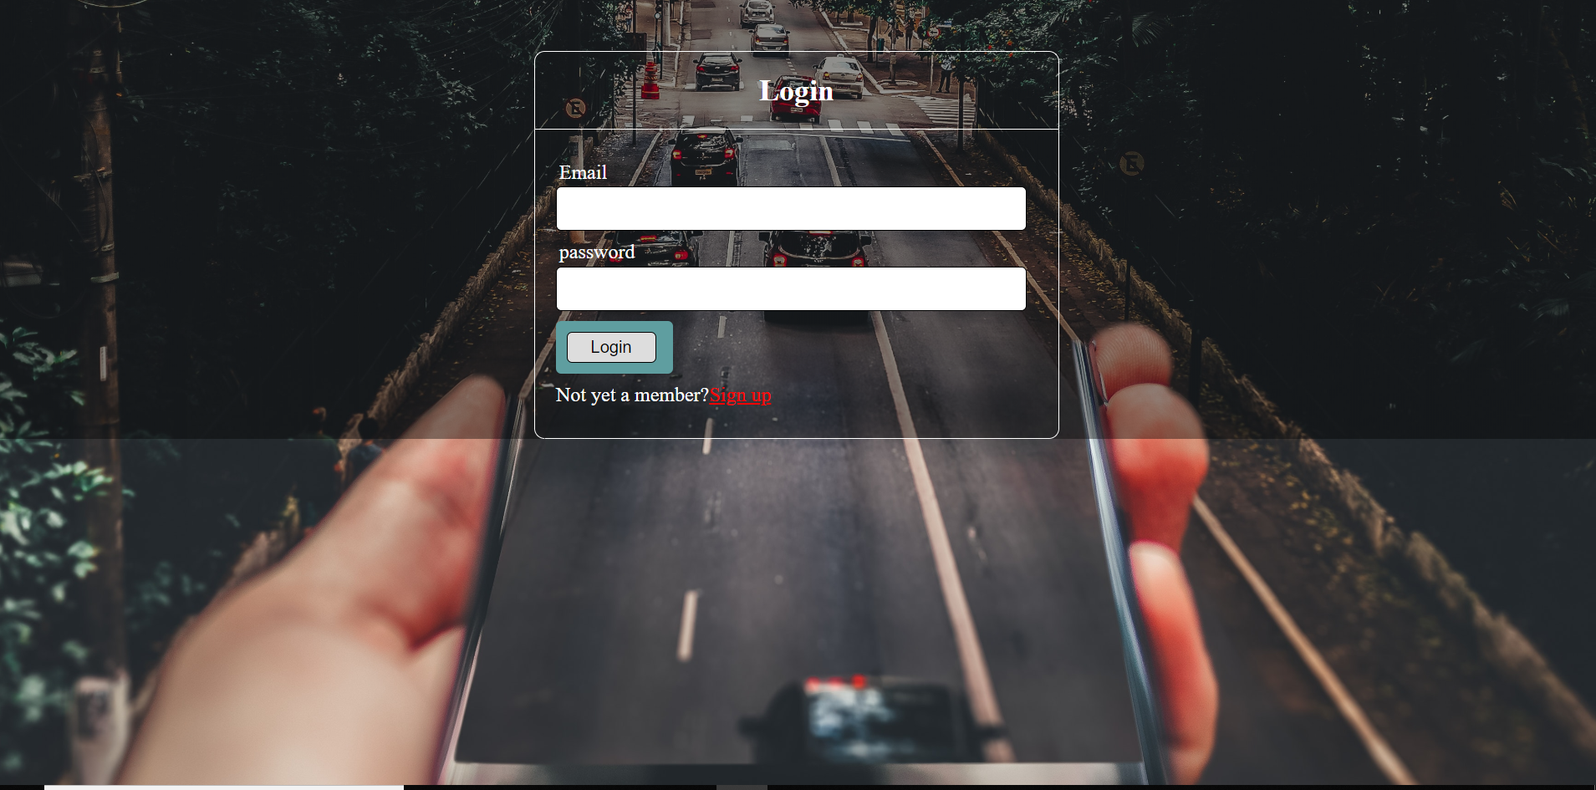

**4.) Select Location Page**

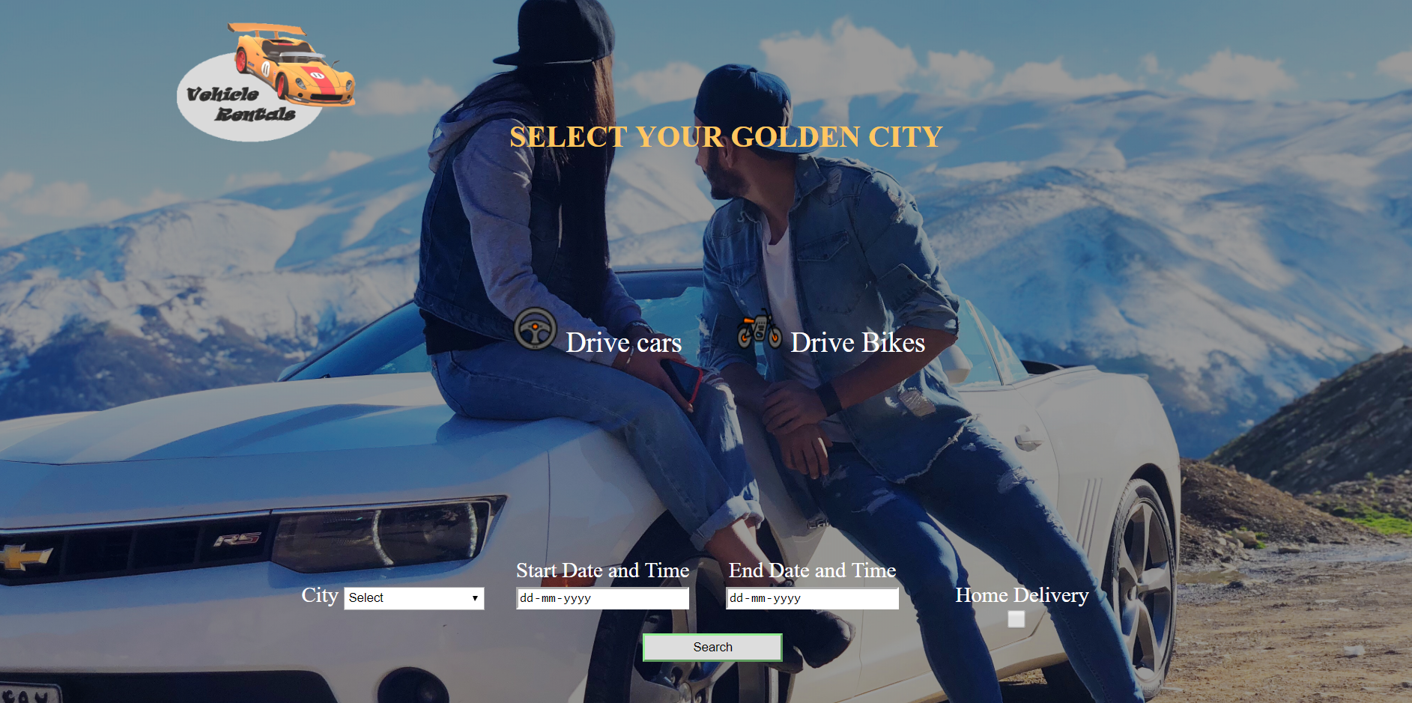

**5.) Confirm Order Page**

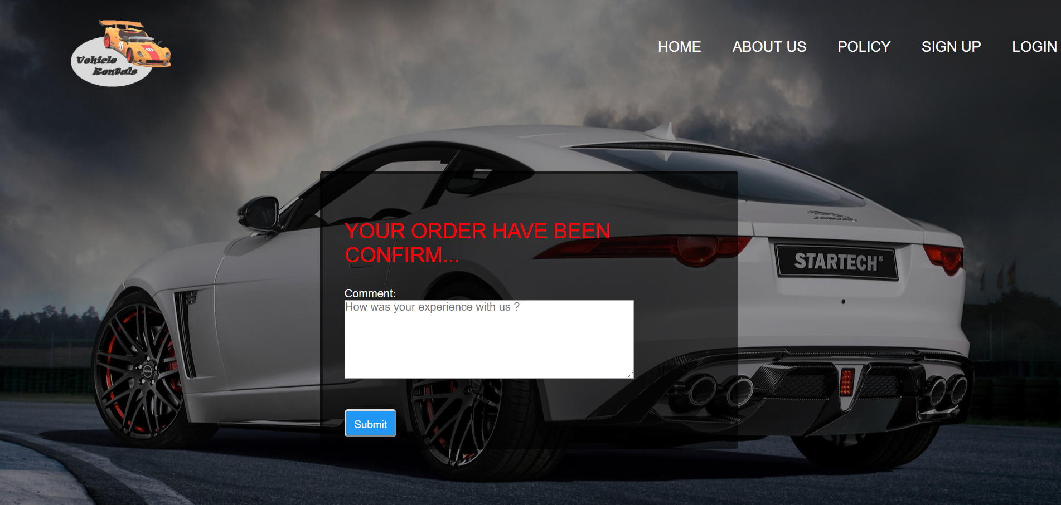

**6.) Select Option Page**

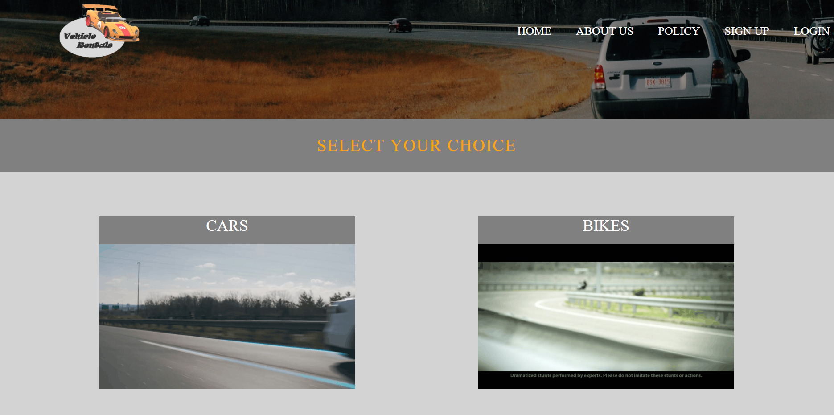

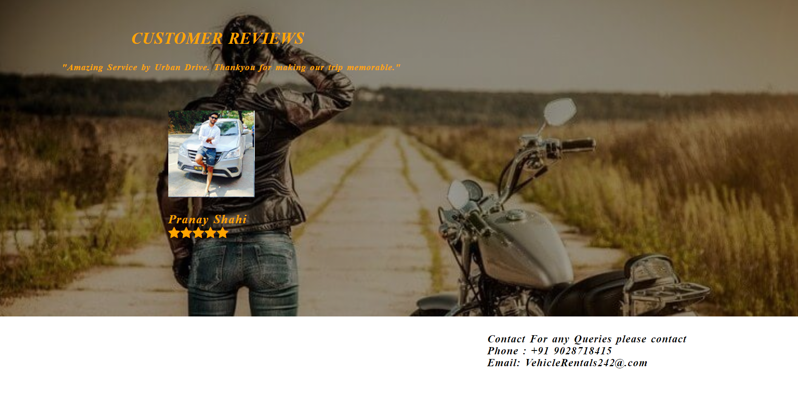

**7.) About Us Page**

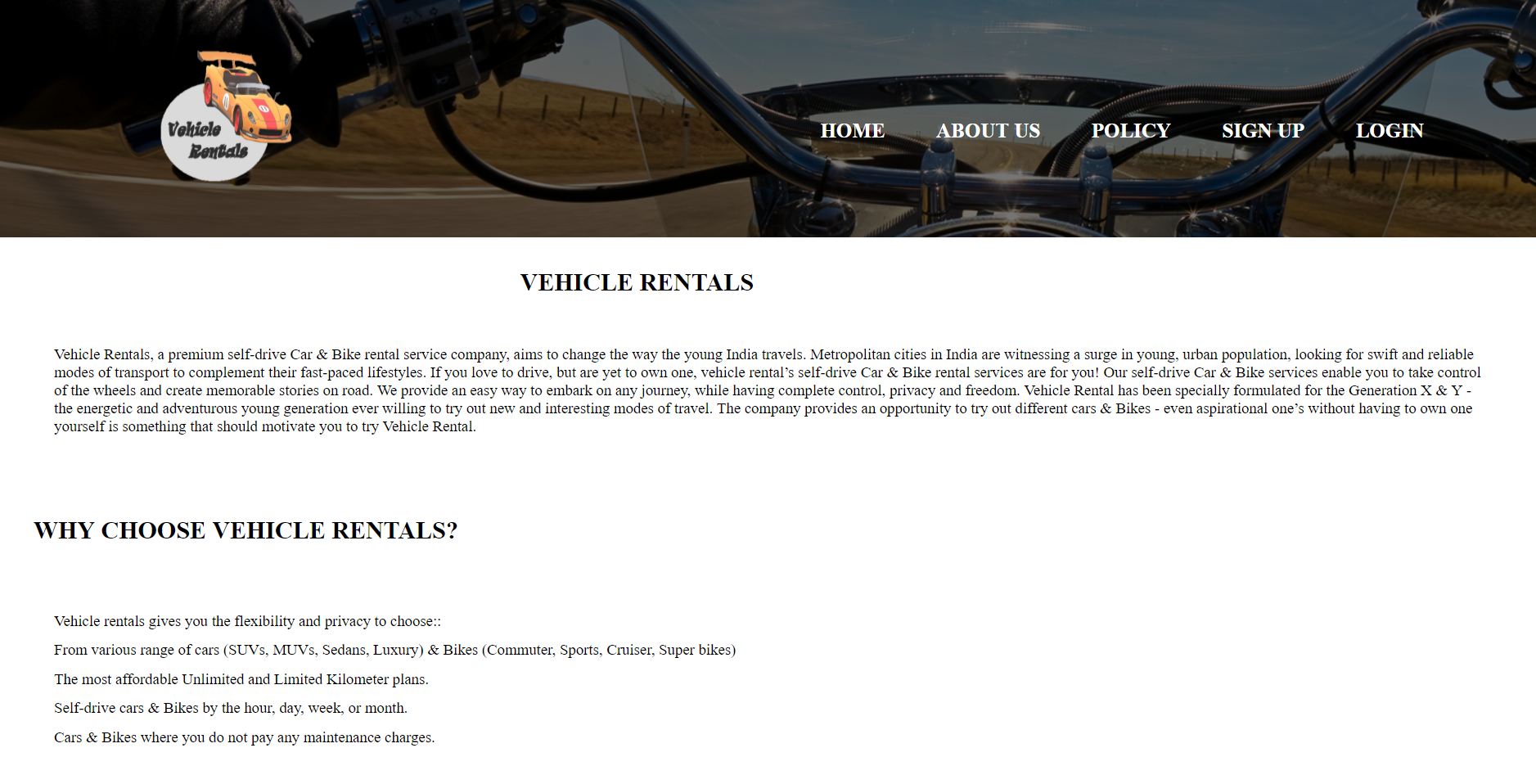

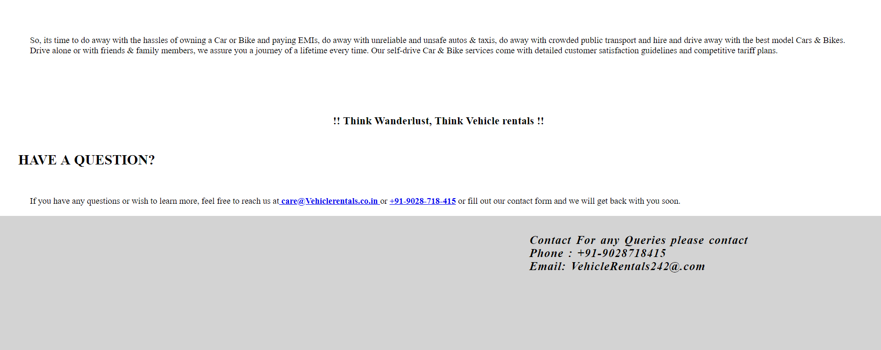

**8.) Policy Page**

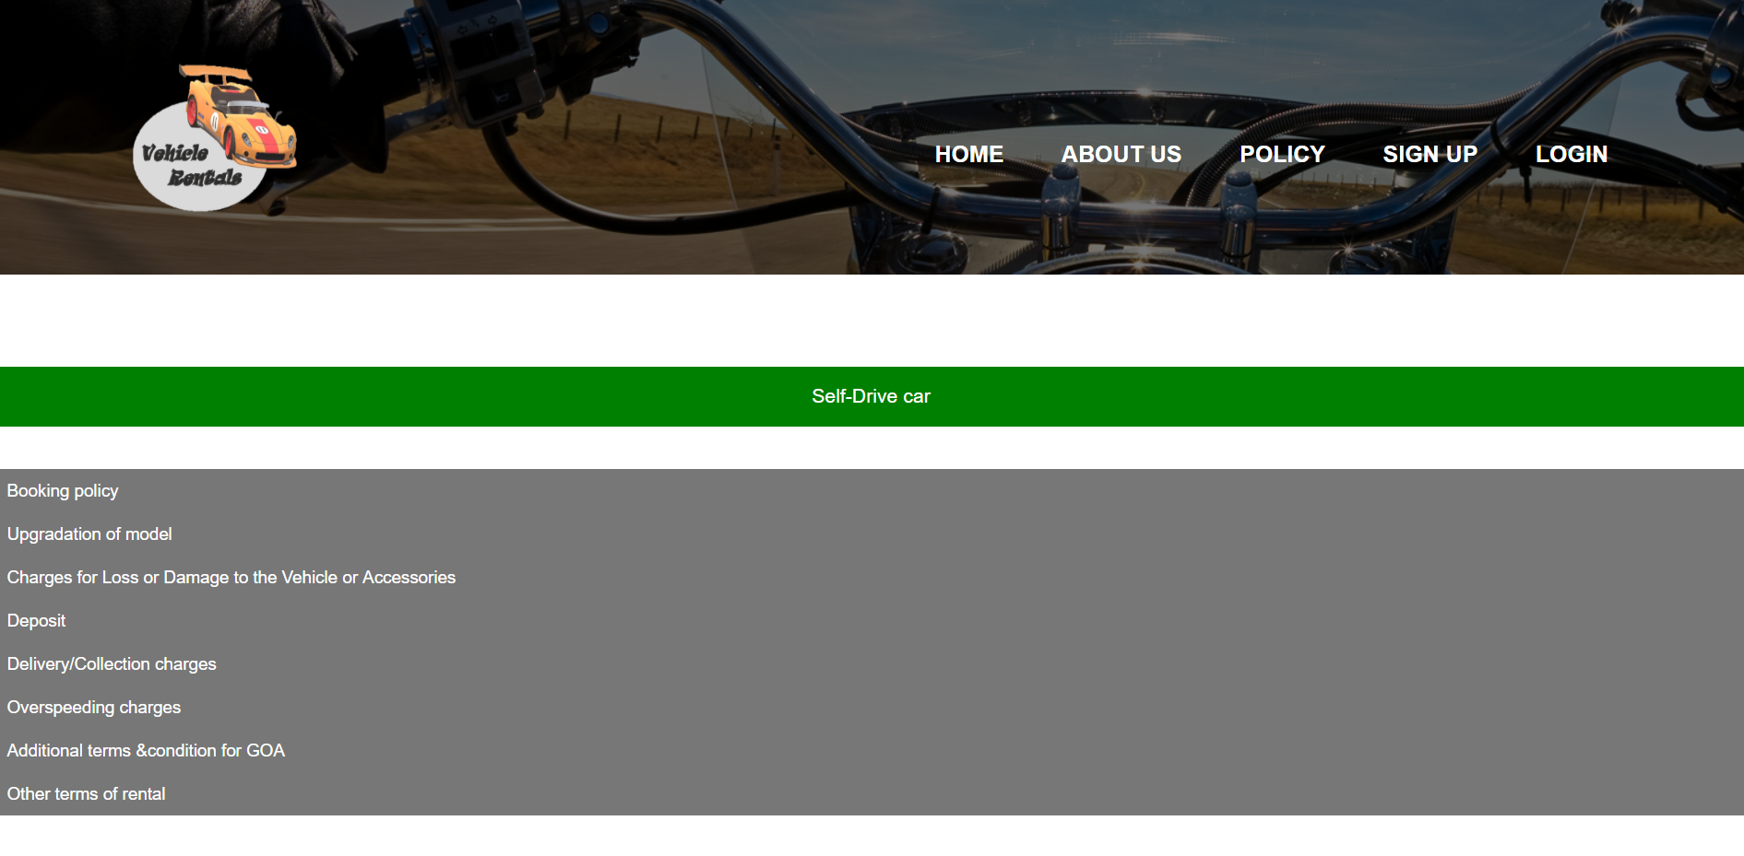

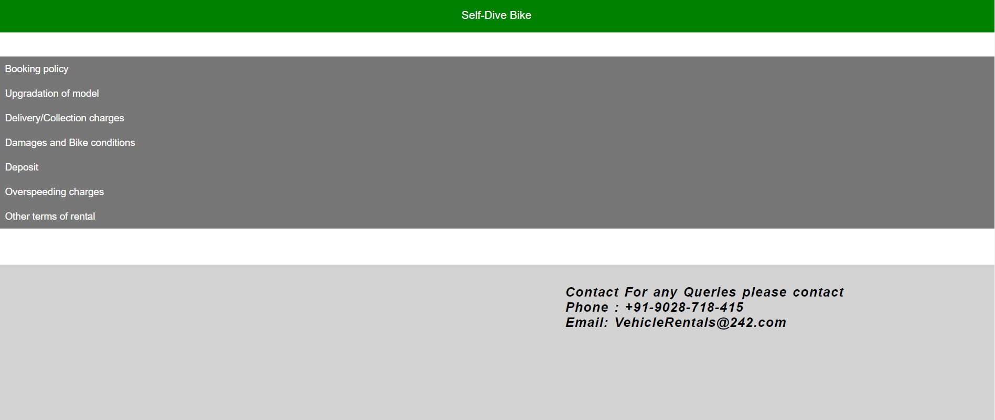

**9.) Order Cars Page**

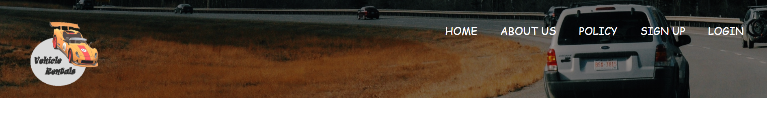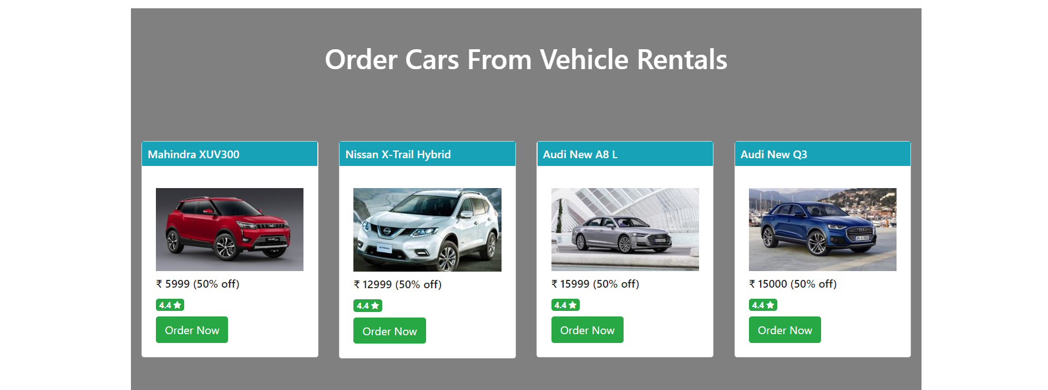

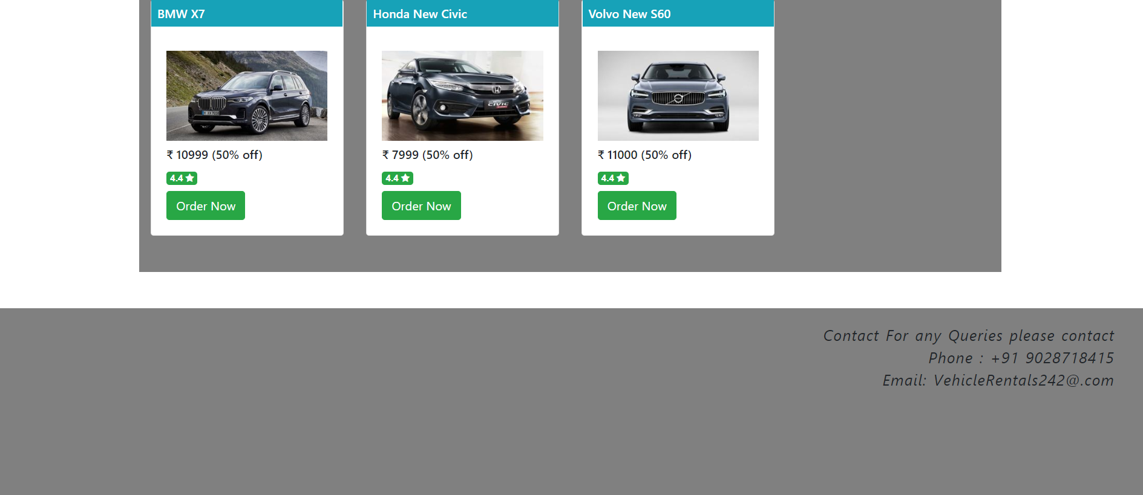

**10.) Order Bikes Page**

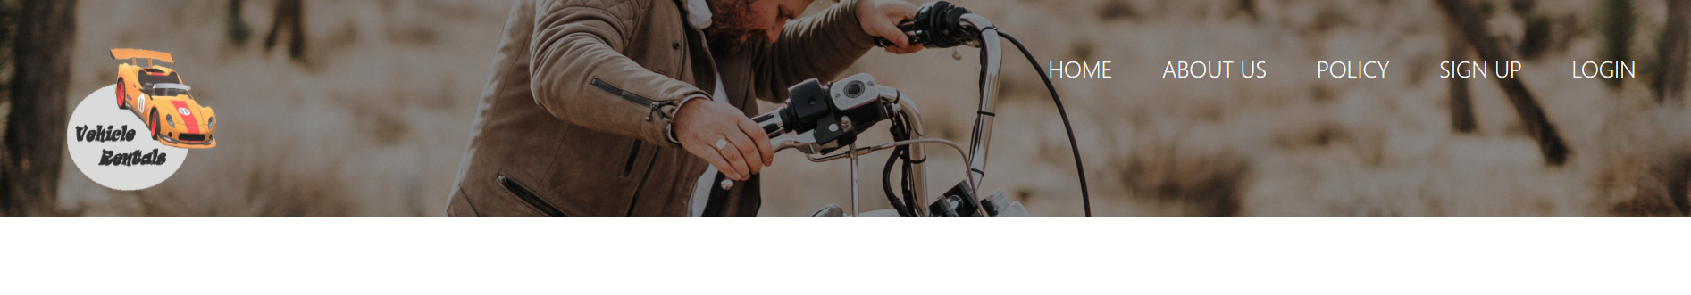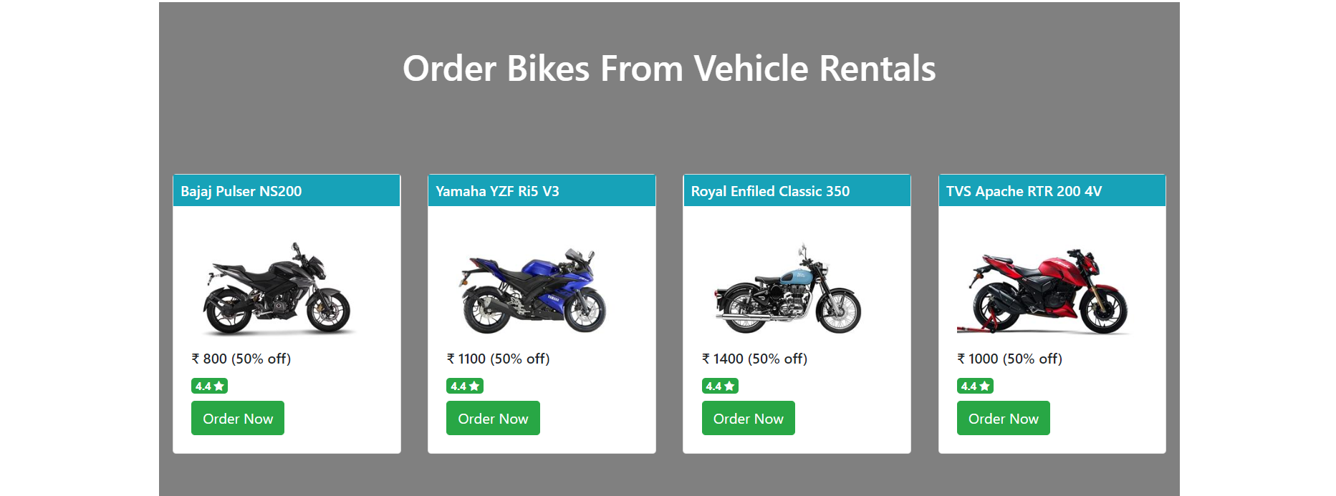

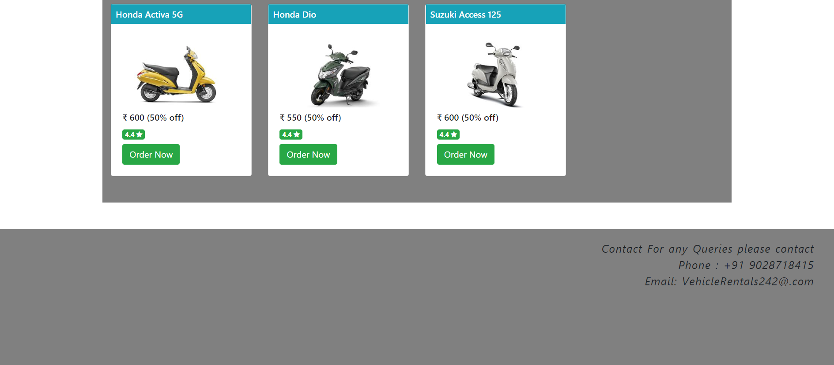

**11.) Booking Form Page**

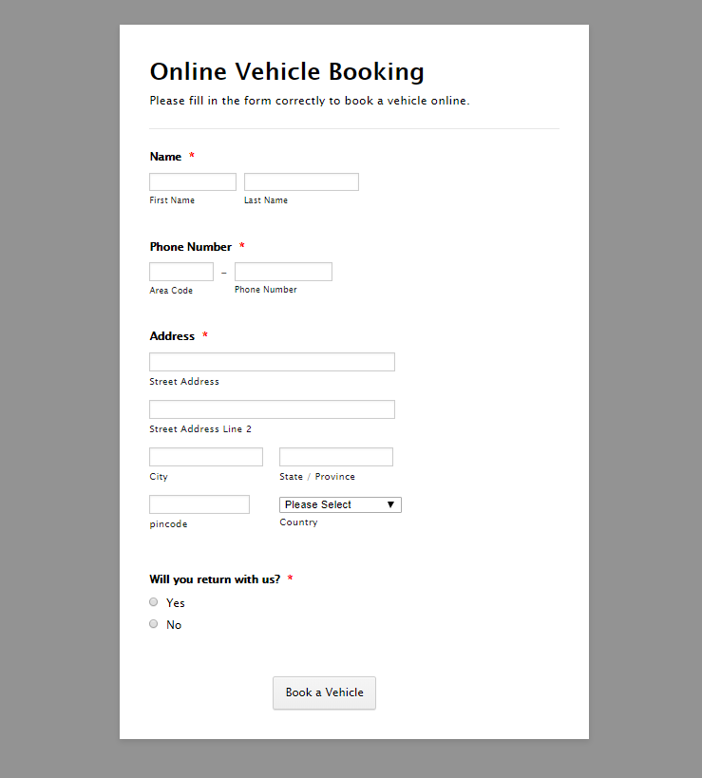

**12.) Map Location Page**

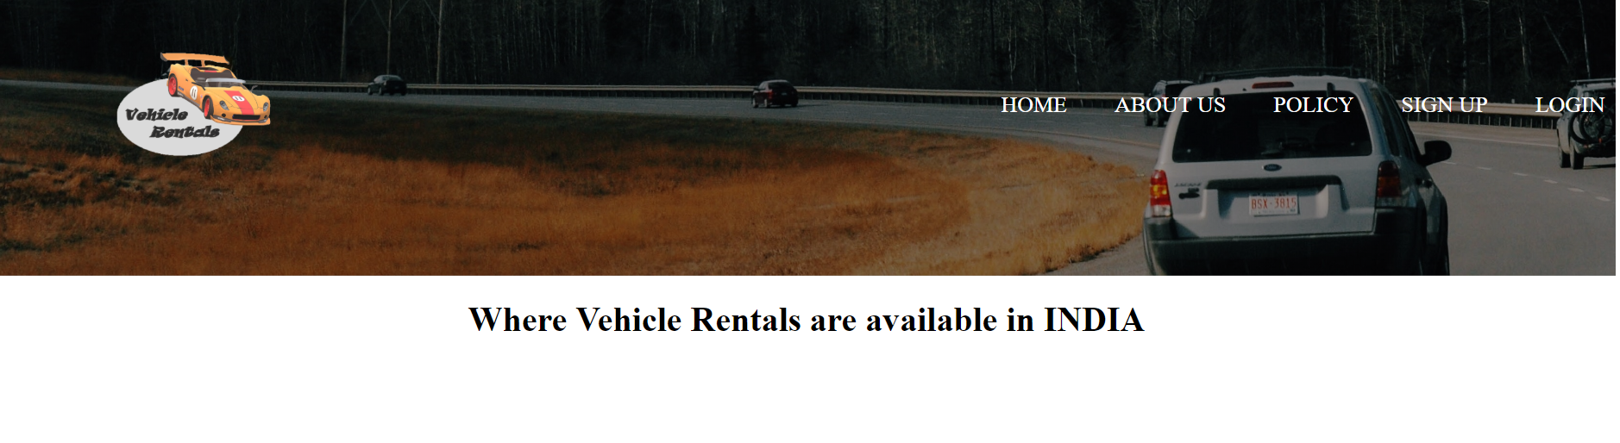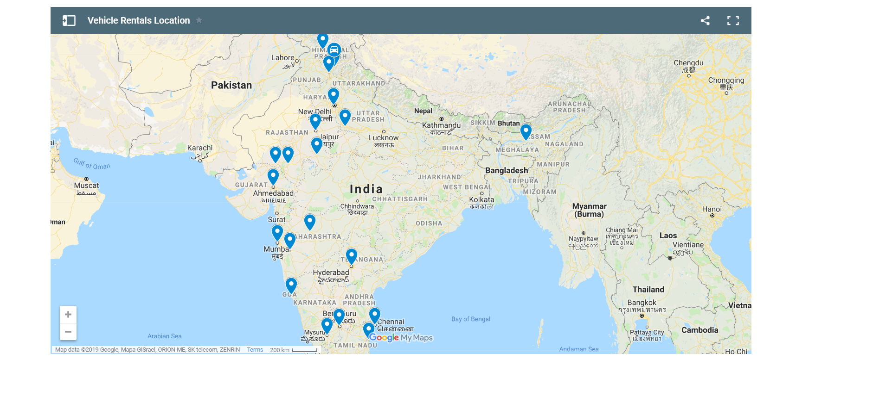

**13.) Payment Form**

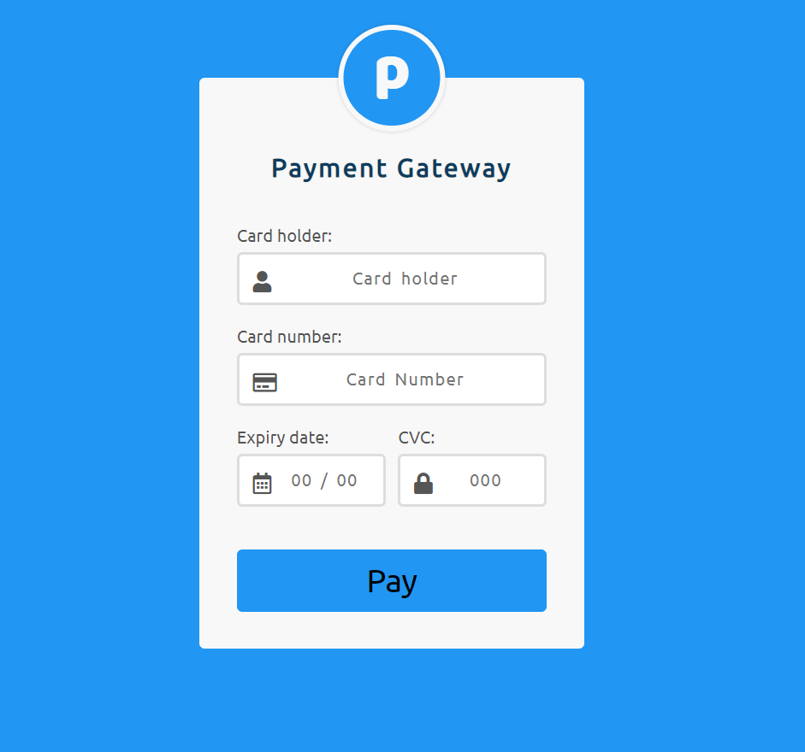

**Enhancement**

This website’s aim is to create a wide network of users . Future scope for this website is as follows :-

* Upgrading details of new famous tourist spot.
* Upgrading major details of new places in various states.
* Instant online payments for user’s.

**Conclusion**

We have created this project as effective and less time consuming. Thus the output of our project results in such a way that user can easily get information of car, book a car and quickly rent a car of his need. The advantages of our project is you can see whether our facilities are available near you by using our Geographical page (map page). This system also provides you with home delivery, which is not available with others. Thus the project is more reliable.

**System limitation**

* This system dosen’t provide edit option
* This system is only valid across India

**Future Scope**

In future we are willing to open new branches of our facilities and also make it more efficient with other benefits. With more categories of vehicle we are making it more efficient. We are looking to make it more convenient as for availability of vehicle. We are looking to make it cost efficient and more tasks efficient. We will make it less time consuming.

This project can also be extended if there are other vehicle option like for example bicycles, autorickshaws and other more vehicles.

**Reference**

**Books :-**

1. PHP:The complete reference

- Steven Holzer

1. Database management system (DBMS)

- Dr. Rajiv Chopra

1. Mysql tutorials for beginners

- Dennis Hutten

**Websites :-**

1. [https://www.google.com.qa/maps/d/edit?mid=1RrCYASUfulW27sRLhFdTdL3V2liYMG3j&ll=32.24404103651009%2C92.73072731346122&z=5](https://www.google.com.qa/maps/d/edit?mid=1RrCYASUfulW27sRLhFdTdL3V2liYMG3j&ll=32.24404103651009,92.73072731346122&z=5)
2. <https://daneden.github.io/animate.css/>
3. <https://www.latlong.net/>